**Project Development Phase Model Performance Test**

|  |  |
| --- | --- |
| Date | 26 November 2022 |
| Team ID | PNT2022TMID49030 |
| Project Name | CAR RESALE VALUE PREDICTION |
| Maximum Marks | 10 Marks |

**Model Performance Testing:**

Project team shall fill the following information in model performance testing template.

|  |  |  |  |
| --- | --- | --- | --- |
| **S.No.** | **Parameter** | **Values** | **Screenshot** |
| 1. | Metrics | **Regression Model:**  MAE - , MSE - , RMSE - , R2 score -  **Classification Model:**  Confusion Matrix - , Accuray Score- & Classification Report - |  |
| 2. | Tune the Model | Hyperparameter Tuning - Validation Method - |  |

1. METRICS

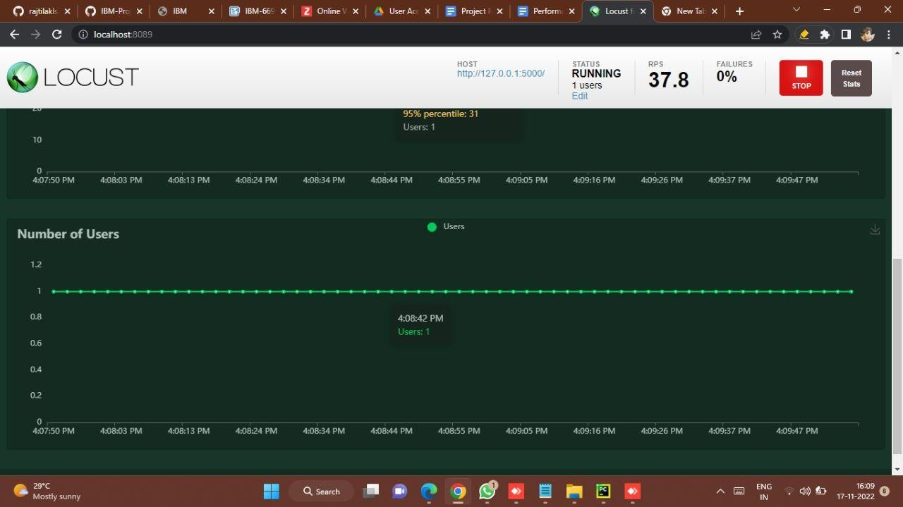

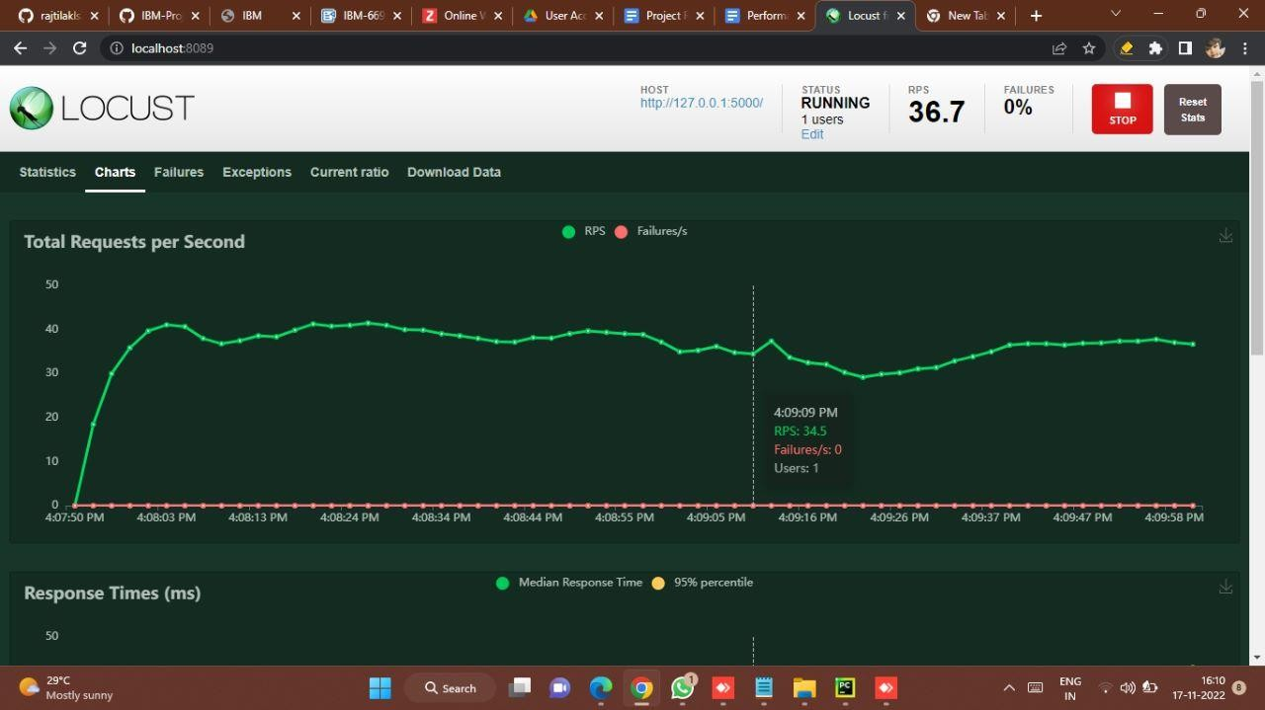

1. TUNING THE MODEL



